Rosbag messages
12/21/22 – I have recorded a bag file (2022-12-21-16-36-01.bag) and need to replay it to check the map. I have created a launchfile that I believe is just for running a bag file.

/home/tractor/catkin_ws/src/lawn_tractor_navigation/launch/rosbag_playback.launch

How to record rosbag data  mkdir ~/bagfiles  cd ~/bagfiles  rosbag record -a | https://wiki.ros.org/rosbag/Tutorials/Recording%20and%20playing%20back%20data  rosbag record -O subset /turtle1/cmd_vel  The -O argument tells rosbag record to log to a file named subset.bag  Test:  mkdir ~/bagfiles  cd ~/bagfiles  rosbag record -O testbag /cmd_vel  rosbag info testbag.bag  rostopic echo -b testbag.bag -p /cmd_vel > testbag_cmd_vel.txt

An improvement would be to write a launch file or some script that only subscribes to the ones you want to review.

ubuntu@ubiquityrobot:~/bagfiles$ rosbag record -a
[ INFO] [1584205488.385952551]: Recording to 2020-03-14-13-04-48.bag.
….

Download the rosbag file from RPi
Open FileZilla
Open directory
$ cd ~/bagfiles

Run a search if needed. It seems I’m all over the place on where I store files

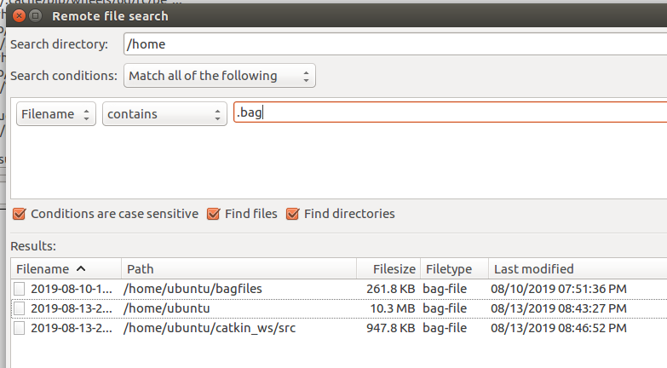
rosbag play -l /home/al/Documents/Al_Jones_2019-08-11-15-52-05.bag
Rosbag play -l /home/al/bagfiles/2019-08-13-20-35-20.bag
-l, --loop #Loop playback.

Start SEC seconds into the bags.
$ rosbag play -s 5 recorded1.bag

$ roscore
$ rosbag play -l /home/al/bagfiles/Al_J_2019-08-14-21-50-21.bag
$ rqt_plot

On RPi
$ cd /home/ubuntu/.ros
$ mkdir bagfiles
$ cd /home/ubuntu/.ros/bagfiles
$ rosbag record -a

Convert bagfiles to csv
/home/al
$ cd ~/bagfiles
$ python /home/al/python/bag_to_csv.py

$ rosbag info session*.bag
2020-06-11-19-47-26.bag
$ cd ~/bagfiles
$ rosbag info 2020-06-11-19-47-26.bag
$ rosbag play -l /home/al/bagfiles/2020-06-11-19-47-26.bag

$ rosbag play -l /home/al/bagfiles/2020-06-11-19-47-26.bag
$ rosbag play -l /home/ubuntu/Downloads/2020-06-11-19-47-26.bag

Ubuntu laptop directory: /home/al/.ros/bagfiles/

$ cd /home/al/.ros/bagfiles/
$ rosbag play -l 2020-08 {tab}

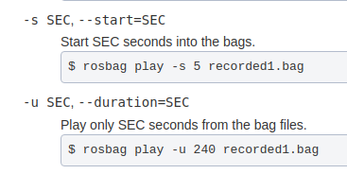
$ rosbag play -l --start=60 --duration=30 2020-08-08-15-02-27.bag

8/22/20
$ cd /home/al/.ros/bagfiles/
$ rosbag play -l 2020-08-22-15-50-39.bag
$ rosbag play -l --start=310 2020-08-22-15-50-39.bag

- Optional - If you want/need the laptop to be the ROSMASTER you need to modify the ROS_MASTER_URI in your /home/{user}/.bashrc file so the ROS_MASTER_URI is set to your laptop performing the simulation. ( Use $ nano ~/.bashrc) or find .bashrc in /home/{user} directory and open with Sublime or another editor.

- Comment out tractor_aj
- Add ROSMASTER for local
- Save and $ source ~/.bashrc
If you launch and the MASTER appears as the tractor, that is a problem

12/6/20
$ cd /home/al/.ros/bagfiles/
$ rosbag play -l 2020-12-06-15-09-33.bag
$ rosbag play -l --start=90 2020-12-06-15-09-33.bag
- $ rostopic echo /move_base_flex/exe_path/goal

3/6/2021
$ rosbag play -l /home/al/bagfiles/2021-03-06-14-04-26.bag
-l, --loop #Loop playback.

$ rosbag play -l /home/al/bagfiles/2021-03-06-15-42-28.bag

4/24/2021
$ rosbag play -l /home/ubuntu/.ros/bagfiles/2021-04-24-14-52-40.bag

5/1/2021
$ cd /home/al/.ros/bagfiles/
$ rosbag play -l /home/ubuntu/.ros/bagfiles/2021-05-01-19-42-17.bag.active

11/28/2021
$ rosbag play -l /home/ubuntu/.ros/bagfiles/2021-11-28-15-14-22.bag

